Mid Term Exam

**90 minutes - 40 marks Monday, 24 May 2021**

* Code clearly, Use proper English for better understanding of instructor.
* **Open** Books/ **Open** Notes**/Open Mind**
* Do not turn the page until you are told to do so.

|  |  |  |  |  |  |  |  |  |
| --- | --- | --- | --- | --- | --- | --- | --- | --- |
| **Questions** | **1** | **2** | **3** | **4** | **5** | **6** | **7** | **Total** |
| **Marks** |  |  |  |  |  |  |  | **/40** |

# All the best!

Question # 1: (5 Marks)

Following Figure 1 shows the display of web page on computer screen if style is not configured for Print option. We wanted to display the Print layout of the page when print web page option is selected.

Write and explain the code that choose the print style of the web page when print web page option is selected.

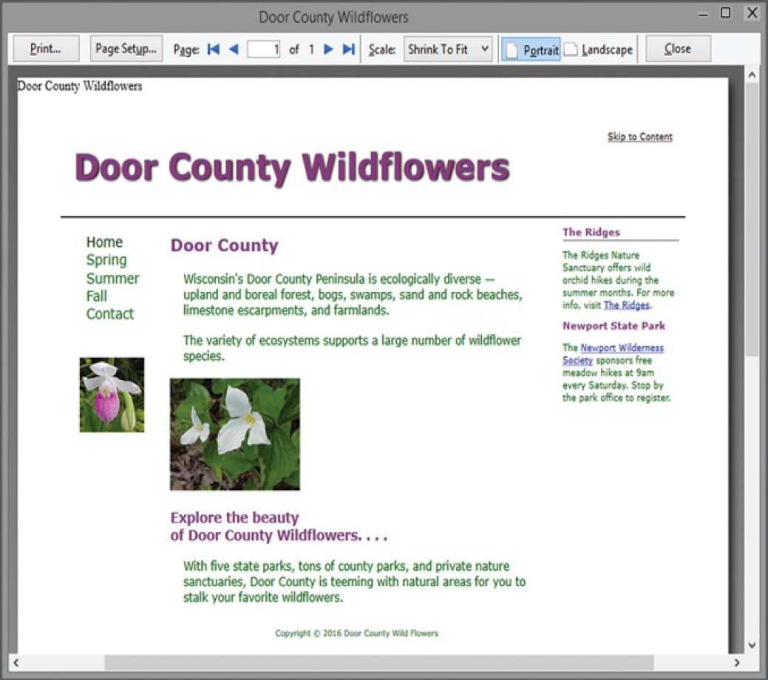

Figure 1: Computer Screen Display of Web page

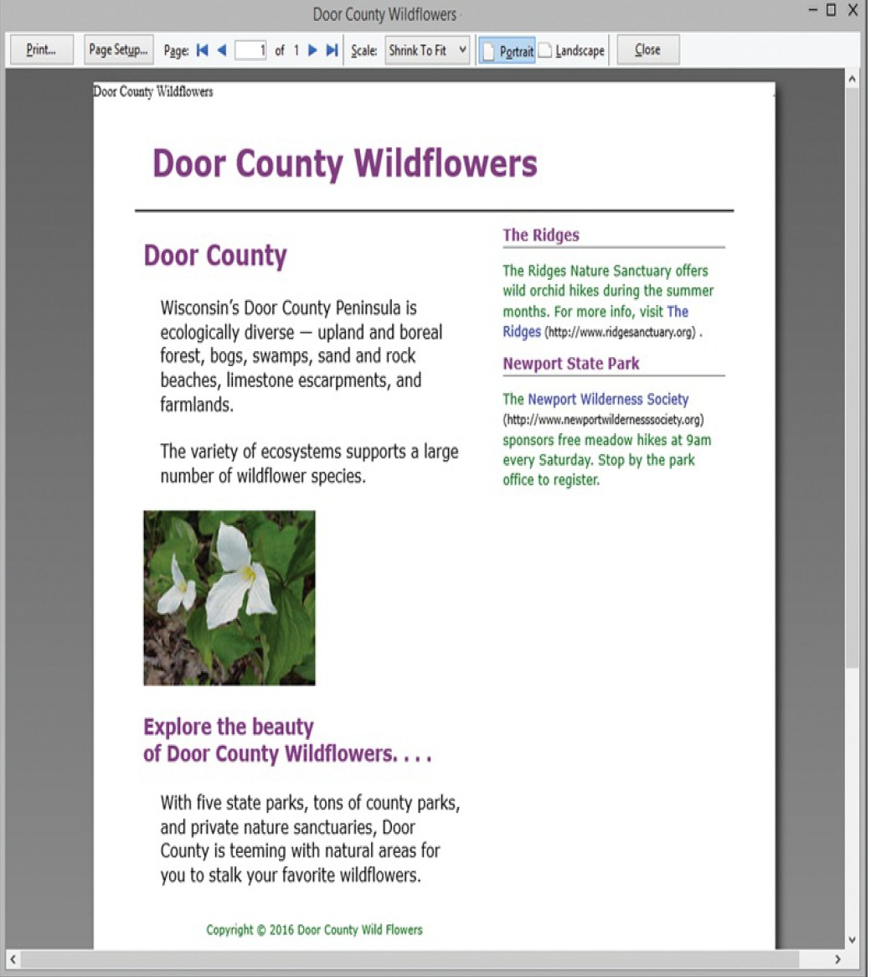

Figure 2: Print Display of Web Page

Answer

header a { display: none; }

main {

margin: 0 40% 0 0; (set margin of the main element from right to 40%)

font-size: 12pt; (set font size of the text to 12pt)

}

h1 {

font-size: 24pt; (set font size of the text to 24pt)

}

nav { display: none; }

aside a { text-decoration: none; } (set the text decoration to none like no underline & overline etc);

aside a:after

{

content: " (" attr (href) ") ";

font-size: 8pt; (set font size of the text to 8pt)

color: #000000; (set color of the text to #000000)

}

.news { font-size: 10pt; } (set font size of the text to 10pt)

Question # 2: (5 Marks)

Explain the bold code in the above CSS codes? What type of image is this sprites.gif? Why we use them in our web applications?

Consider the following code

nav a {

text-decoration: none; display: block; padding: 20px;

background-color: #b3c7e6; border-bottom: 1px solid #ffffff; **background-image: url(sprites.gif); background-repeat: no-repeat; background-position: right 0;**

}

nav a:hover {

background-color: #eaeaea; color: #869dc7;

**background-position: right -100px;**

}



**Figure 3: sprites.gif**

Answer:

1. Code Description

|  |  |
| --- | --- |
| Line No: | Description |
| 1 | The code “background-image: url (sprites.gif)” set the sprites.gif image as the background-image of the element (nav a). |
| 2 | The code “background-repeat: no-repeat” means that the background-image will not repeat itself. |
| 3 | The code “background-position: right 0” means that the position of the background-image is on right-side with the offset value 0 from the top. |
| 4 | The code background-position: right -100px” means that the position of the background-image is on right-side with the offset value 100 from the top. |

1. What type of image is this sprites.gif?

The sprites images are the collection of many images which collectively generate a single image as sprites.gif as .gif .

1. Why we use them in our web applications?

We use the spritie.gif type images to reduce the number of server requests and save bandwidth.

Question # 3: (5 Marks)

Write the Code to show working of Block Anchor putting paragraph or div within anchor tag that would open facebook.com in new Window? Also show my number phone in the anchor tag such that when user taps on the Phone number, call is made to my number, again show my number phone in the anchor tag such that when user taps on the Phone number, an SMS app is open with my number written in the text and option to write SMS text.

Answer:

<!DOCTYPE html>

<html lang="en" dir="ltr">

<head>

<meta charset="utf-8">

<title>Question 3</title>

</head>

<body>

<h2>Facebook</h2>

<a href="https://www.facebook.com" target="_blank"><div>Facebook</div></a>

<h2>Phone No: </h2>

<a href="tel:03004200045" target="_blank"><div>03004200045</div></a>

<h2>Send Message</h2>

<a href="sms:03004200045" target="_blank"><div>03004200045</div></a>

</body>

</html>

Question # 4: (5 Marks)

Consider the following hierarchy of the website. Suppose that you are editing the code of canyon.html file in rooms folder. In the code, you wanted to give the link of festival.html file in the events folder. Write the anchor tag to open the festival.html in the code of canyon.html file.

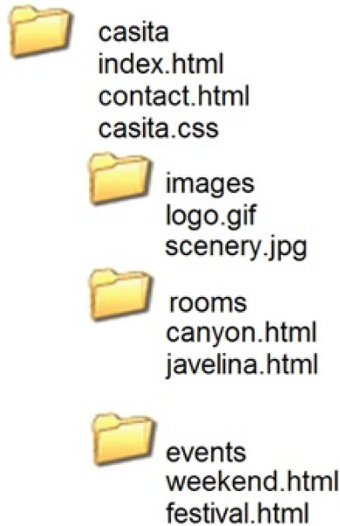

**Figure 4: Folder hierarchy of Casita website**

**Answer**

<**img src="/casita/events/festival.html";**

Either/or

<img src="/events/festival.html";

Question # 5: (5 Marks)

Explain the reason for each line code in the below CSS codes?

nav a {

text-decoration: none;

padding: 20px; display: block;

background-color: #B3C7E6; border-bottom: 1px solid #FFFFFF;}

nav a:link {

color: #FFFFFF; }

nav a:visited {

color: #EAEAEA;

}

nav a:hover {

color: #869DC7;

background-color: #EAEAEA ;}

**Answer:**

|  |  |
| --- | --- |
| **Line No:** | **Description** |
| **1** | The “text-decoration: none” means that their will not be any decorations implemented on the (nav anchor tag text) like “underline”, ”overline” etc. |
| **2** | The “Padding:20px” means that the element (nav anchor tag) has padding area or space from all four sides. |
| **3** | The “display: block” means the element will be displayed as block-type and no other html element will comes next to it but they can order wise. |
| **4** | The “background-color: #B3C7E6” means the element will set the background-color light blue. |
| **5** | The “border-bottom: 1px solid #FFFFFF” means the element will have a border of 1px thick from all sides which type of solid, and the border color will be white or #FFFFFF; |
| **6** | The (nav a:link) CSS code “color: #FFFFFF” means that the anchor tag (links) of nav element will have the color #FFFFFF. |
| **7** | The (nav a:visited) CSS code “color: #EAEAEA” means that when a user will visit the anchor tags(links) of nav elements, the **clicked link** color will change to #869DC7. |
| **8** | The (nav a: hover) CSS code “color: #869DC7” means when a user will move its curser on the link, it’s color will change to #869DC7; |
| **9** | The (nav a: hover) CSS code “background-color: #EAEAEA” means when a user will move its curser on the link, it’s background-color will change to #EAEAEA; |

Question # 6: (5 Marks)

What is CSS box-sizing property and why we prefer to write the following code in CSS file? Explain below line of code. What would happen if we do not write this code in the CSS file?

* { box-sizing: border-box; }

Answer:

|  |  |
| --- | --- |
| Line No | Description |
| 1 | **T**he code “ * { box-sizing: border-box; }” set the border around all elements of the html file. |

What is CSS box-sizing property and why we prefer to write the following code in CSS file?

The box sizing property allows us to include the padding and border in an element's total width and height. We prefer to use this kind of default styling that our browser use for the different elements like “table”, “button” or “input” etc.

What would happen if we do not write this code in the CSS file?

In case if we will not write this code **“** * { box-sizing: border-box; }**”,** Our html elements will not be enclosed in a box or will not have border around the whole html page.

Question # 7: (10 Marks)

Following code is generating the web page as shown in the figure 5 but we wanted to display it as shown in the Figure 6 as below. Explain the problem with the figure 5 and its reason in the code, how would you change the code to correc and make it look like in Figure 6.

Answer:

<!DOCTYPE html>

<html lang="en">

<head>

<title>CSS Float</title>

<meta charset="utf-8">

<style>

body {width: 500px; background-color: #FFFFFF; color: #000000;

}

div {background-color: #F3F1BF;

}

h1 { background-color: #658B42; padding: 10px;

color: #E1DB5F;

}

p { font-family: Arial,sans-serif;

}

.float { float: left; margin-right: 10px;

border: 3px ridge #000000;

}

</style>

</head>

<body>

<h1>Yellow Lady Slipper</h1>

<div>

<img class="float" src="yls.jpg" alt="Yellow Lady Slipper" height="100" width="100">

<p>The Yellow Lady Slipper grows in wooded areas and blooms in June each year. The flower is a member of the orchid family.</p>

</div>

<h2>Be Green When Enjoying Wildflowers</h2>

<p>Enjoy wild plants in their native surroundings. Protect their environment in all possible ways &mdash; support organizations dedicated to preserving their habitat. </p>

</body>

</html>

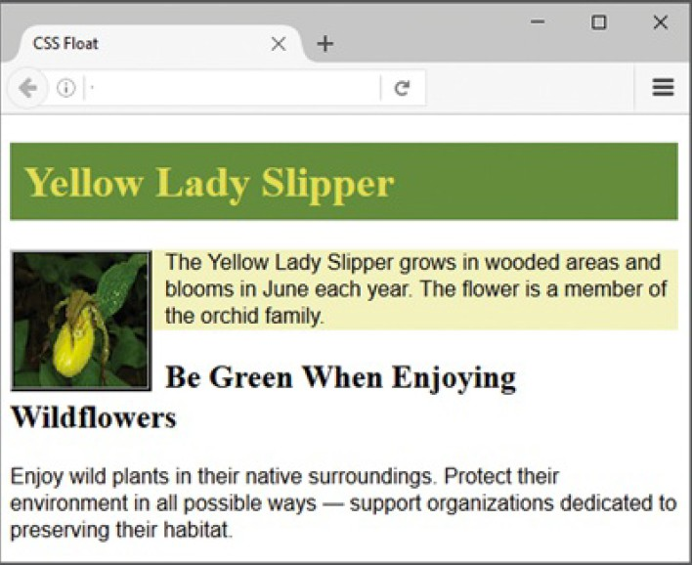

Figure 5: Web Page Out of above code

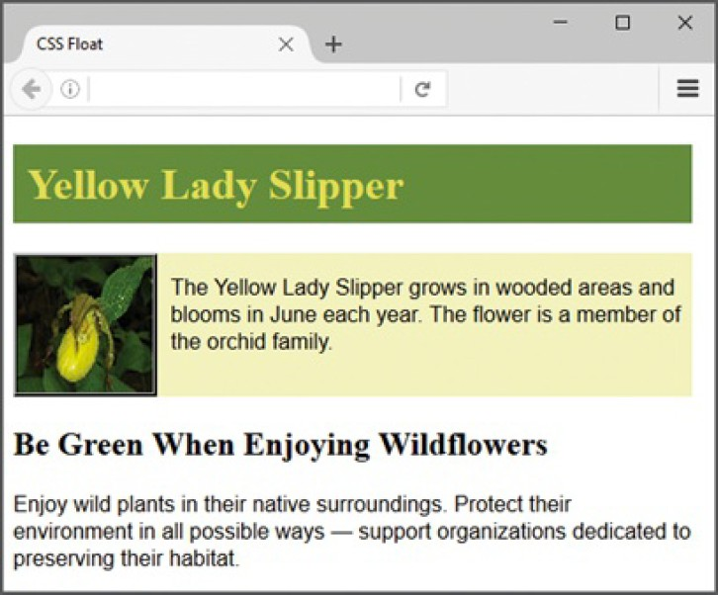

Figure 6: Web Page Required output

Answer:

<!DOCTYPE html>

<html lang="en">

<head>

<title>CSS Float</title>

<meta charset="utf-8">

<style>

body {width: 500px; background-color: #FFFFFF; color: #000000;

}

div {background-color: #F3F1BF;

}

h1 { background-color: #658B42; padding: 10px;

color: #E1DB5F;

}

p { font-family: Arial, sans-serif;

}

.float { float: left; margin-right: 10px;

border: 3px ridge #000000;

}

h2{

margin-top: 60px;

}

.para1 {

padding-top: 20px;

padding-bottom: 30px;

}

</style>

</head>

<body>

<h1>Yellow Lady Slipper</h1>

<div>

<img class="float" src="yls.jpg" alt="Yellow Lady Slipper" height="100" width="100">

<p class="para1">The Yellow Lady Slipper grows in wooded areas and blooms in June each year. The flower is a member of the orchid family.</p>

</div>

<h2>Be Green When Enjoying Wildflowers</h2>

<p>Enjoy wild plants in their native surroundings. Protect their environment in all possible ways &mdash; support organizations dedicated to preserving their habitat. </p>

</body>

</html>

Screenshot:

